UML CLASS DIAGRAM DESIGN
Practical: Object-Oriented Analysis of an Online Grocery Store System

1. Aim
To perform object-oriented analysis of the Online Grocery Store System by identifying its classes, attributes, methods, and relationships, and to represent the system using a UML class diagram.

2. Introduction
A UML (Unified Modeling Language) class diagram is a structural diagram that shows the classes of a software system, their data, their operations, and the relationships between them. It helps developers understand the system before implementation and provides a clear blueprint for designing code.

3. Class Diagram of the Project
The following class diagram represents an Online Grocery Store System. It shows how users, products, carts, orders, payments, delivery partners, and other components are organized and connected.
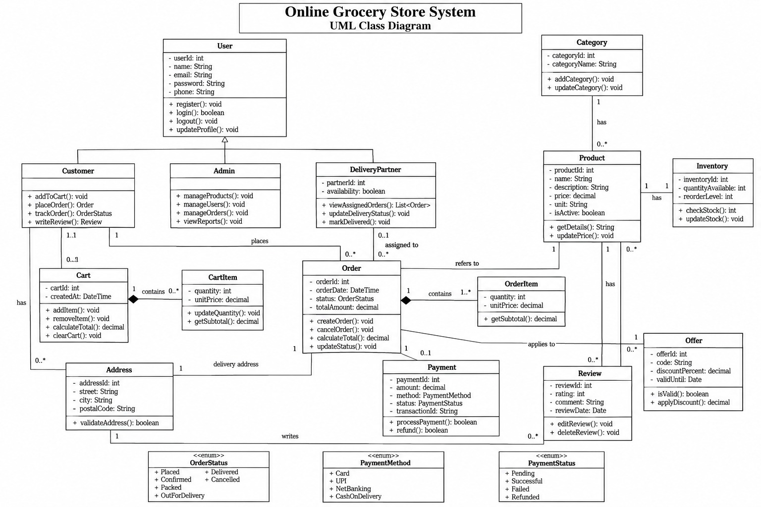
Figure 1: UML Class Diagram of the Online Grocery Store System

4. Main Classes, Attributes and Methods
- User: Stores common user details such as user ID, name, email, password, and phone number. It supports registration, login, logout, and profile updates.
- Customer: Represents a buyer. It can add products to the cart, place orders, track orders, and write reviews.
- Admin: Manages products, users, orders, and reports.
- Product and Category: Product stores details such as name, description, price, unit, and active status. Category groups related products.
- Cart and CartItem: Cart stores selected items before checkout. CartItem records each item's quantity and unit price.
- Order and OrderItem: Order stores order date, status, and total amount. OrderItem records the products and quantities included in an order.
- Payment: Stores payment amount, method, status, and transaction ID, and supports payment processing and refunds.
- Inventory: Tracks available quantity and reorder level for each product.
- DeliveryPartner and Address: DeliveryPartner handles assigned deliveries and updates delivery status. Address stores delivery location details.
- Review and Offer: Review stores customer ratings and comments. Offer represents discounts with a code, percentage, and validity date.

5. Relationships Between Classes
The diagram uses inheritance, associations, and composition to show how classes work together. Customer, Admin, and DeliveryPartner inherit common details and operations from User. A Category can contain multiple Products, while each Product belongs to a Category. A Cart contains CartItems, and an Order contains OrderItems; the filled diamond indicates composition, meaning these items are treated as parts of their respective cart or order. Customers place orders, orders are linked to delivery addresses and payments, and delivery partners can be assigned to orders. Products are also connected to inventory, reviews, and offers.

6. Conclusion
The UML class diagram provides a simple view of the static structure of the Online Grocery Store System. It identifies the main classes, their attributes and methods, and the relationships needed to support product browsing, cart management, ordering, payment, inventory, delivery, reviews, and discounts. This design can be used as a reference while developing the software.

